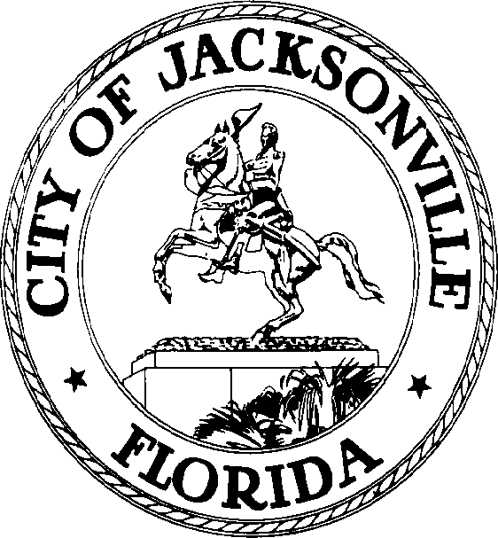

SAM C. NEWBY  Council President Group 5, At-Large  E-Mail: snewby@coj.net | OFFICE OF THE CITY COUNCIL | 117 West Duval Street City Hall, Suite 425  Jacksonville, Florida 32202  Office (904) 255-5219  Fax (904) 255-5230

NOTICE

FEBRUARY 25, 2022
11:30 A.M.

Notice is hereby given that the Jacksonville City Council will meet for the purpose of hosting the 2022 Special Swearing-In Ceremony for Council Member-Elect Nick Howland, Group 3 At-Large scheduled for 12:00 p.m. on Wednesday, March 2, 2022, at City Hall 117 W. Duval Street, Council Chamber, Jacksonville, Florida 32202.

Jacksonville City Council Members, Constitutional Officers, Judges, Duval Delegation, and Congressional Representatives, Appointed Board and Commission members of the City of Jacksonville, the public, and all other interested parties are invited to attend. Invitations are not required to attend this event.

Pursuant to the American with Disabilities Act, accommodations for persons with disabilities are available upon request. Please allow 1-2 business days' notification to process; last-minute requests will be accepted but may not be possible to fulfill. Please contact Disabled Services Division at: V (904) 255-5466, TTY (904) 255-5476, or email your request to KaraT@coj.net.

Please contact the Yvonne P. Mitchell at 904.255-5171 for additional information.

SN/ypm

XC: Council Members
Cityc@coj.net
Jessica Matthews, Chief, Legislative Services Division
Jeff Clements, Chief, Research Division
Margaret “Peggy” Sidman, OGC
Jason Gabrielle, OGC
City Council Calendar
Electronic Posting – 1st Floor City Hall
Web Posting
Media

